

***System Provisioning and Configuration Management***

***Submitted by:***

***NAME: Tanishqua Tellakula***

***SAP ID: 500084269***

***Roll number: R120220007***

***Batch: B1(Hons)***

***EXPERIMENT 3***

**Terraform IAM User Setting**

***Prerequisites: Terraform Installed: Make sure you have Terraform installed on your machine. Follow the official installation guide if needed.***

*AWS Credentials: Ensure you have AWS credentials (Access Key ID and Secret Access Key) configured. You can set them up using the AWS CLI or by setting environment variables.*

***Exercise Steps:***

***Step 1: Create a New Directory:***

*Create a new directory for your Terraform configuration:*

*“****Terraform-Demo”***

***Step 2: Create Terraform Configuration File (main.tf):***

*Create a file named main.tf with the following content:*

| ***terraform {***  ***required_providers {***  ***aws = {***  ***source = "hashicorp/aws"***  ***version = "5.31.0"***  ***}***  ***}***  ***}***  ***provider "aws" {***  ***region     = "ap-south-1"***  ***access_key = "your IAM access key"***  ***secret_key = "your secret access key"***  ***}*** |
| --- |

*This script defines an AWS provider and provisions an EC2 instance.*

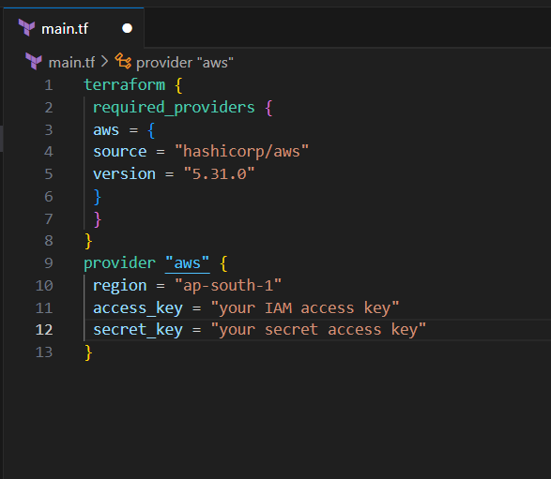

***Step 3: Initialize Terraform:***

*Run the following command to initialize your Terraform working directory:*

| **terraform init** |
| --- |

